A
RAJALAKSHMI INSTITUTE OF TECHNOLOGY

KUTHAMBAKAM, CHENNAI - 600 124



DIGITAL SYSTEMS

Laboratory Record Note Book

Name : Priyadarshan V J
University Reg. No : 211719104096
College Roll No : 201901096
Subject Code : CS8382
Subject Name : Digital Systems Laboratory
Branch : Computer Science and Engineering
Semester : 3rd
Academic Year : 2020 -2021

RAJALAKSHMI INSTITUTE OF TECHNOLOGY
KUTHAMBAKKAM, CHENNAI - 600124

BONAFIDE CERTIFICATE

NAME …Priyadarshan V J …………………………………………………………
ACADEMIC YEAR…2020-2021…….YEAR…2nd…..BRANCH…CSE…………

UNIVERSITY REGISTER NO: 211719104096

Certified that this is the Bonafide record of work done by the above student in the …… Digital Systems …………………laboratory during the academic year 2020 – 2021.

Signature Signature
Faculty-in-charge HOD

Submitted for the Practical Examination held on …………………..

Internal Examiner External Examine
RIT - INDEX
Name : Priyadarshan V J Branch : CSE Sec : B Roll No : 201901096

S.No | Date | Title | Page No. | Teacher's Sign/Remarks
1 | 19.09.2020 | Study and verification of logic gates.
2 | 19.09.2020 | Study and verification of Boolean theorems using basic gates.
3 | 26.09.2020 | Design and implementation of adders and subtractors using logic gates and using IC 7483.
4 | 3.10.2020 | Design and implementation of code converters using logic gates.
5 | 10.10.2020 | Design and implementation of an arbitrary function using logic gates.
6 | 10.10.2020 | Design and implementation of 8-bit magnitude comparator using IC 7485.
7 | 21.10.2020 | Design and implementation of 4-bit, 16-bit odd/even parity checker/ generator using IC 74180.
8 | 21.10.2020 | Implementation of Full adder using multiplexer.
9 | 22.10.2020 | Implementation of SISO, SIPO, PISO and PIPO shift registers using flip-flops.
10 | 22.10.2020 | Construction and verification of 4-bit Johnson counter.
11 | 23.10.2020 | Design and implementation of 3-bit synchronous up/down counter.
12 | 23.10.2020 | Design and implementation of Mod-10/Mod-12 ripple counter.
13 | 27.10.2020 | HDL programs for combinational and sequential circuits.
14 | 27.10.2020 | Mini Project

EX.NO:1
DATE : 19.09.2020
STUDY AND VERIFICATION OF LOGIC GATES
AIM:
To study various logic gates and to verify the truth table.

COMPONENTS / EQUIPMENTS REQUIRED:
S. No. | Components / Equipments | Specification | Quantity
1. | CircuitVerse Software | --- | 1
2. | AND Gate | IC7408 | 1
3. | OR Gate | IC7432 | 1
4. | NOT Gate | IC7404 | 1
5. | NAND Gate | IC7400 | 1
6. | NOR Gate | IC7402 | 1
7. | Ex-Or Gate | IC7486 | 1
8. | Connecting Wires | --- | Sufficient Numbers

LOGIC DIAGRAM:
AND Gate: OR Gate:

NOT Gate: NAND Gate:

NOR Gate: Ex-OR Gate:

OUTPUT:
AND Gate:
Logic Diagram: Truth Table:
A | B | Y=AB
0 | 0 | 0
0 | 1 | 0
1 | 0 | 0
1 | 1 | 1
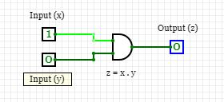
OR Gate:
Logic Diagram: Truth Table:
A | B | Y=A+B
0 | 0 | 0
0 | 1 | 1
1 | 0 | 1
1 | 1 | 1

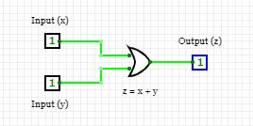

NOT Gate:
Logic Diagram: Truth Table:
A | Y=A’
0 | 1
1 | 0
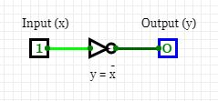

NAND Gate:
Logic Diagram: Truth Table:
A | B | Y=(AB)’
0 | 0 | 1
0 | 1 | 1
1 | 0 | 1
1 | 1 | 0
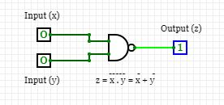

NOR Gate:
Logic Diagram: Truth Table:
A | B | Y=(A+B)’
0 | 0 | 1
0 | 1 | 0
1 | 0 | 0
1 | 1 | 0
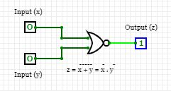

Ex-OR Gate:
Logic Diagram: Truth Table:
A | B | Y
0 | 0 | 0
0 | 1 | 1
1 | 0 | 1
1 | 1 | 0
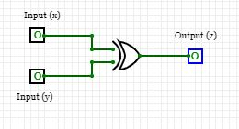

PROCEDURE:
1. Give the connections as per the pin diagram (AND gate).
2. Switch on the trainer kit.
3. Apply the binary inputs at the appropriate terminal and observe the corresponding output.
4. Verify the truth table.
5. Repeat the above procedure for other (OR, NOT, NAND, NOR and Ex-Or) gates.

INFERENCE AND CONCLUSION:
The above logic gates and its truth table were verified.

EX.NO:2
DATE : 19.09.2020

VERIFICATION OF BOOLEAN THEOREMS USING LOGIC GATES

AIM:
To study and verify the truth table of basic logic gates NOT, AND, OR, NAND, NOR and EX-OR and to verify the Boolean theorems.

COMPONENTS / EQUIPMENTS REQUIRED:
S. No. | Components / Equipments | Specification | Quantity
1. | CircuitVerse Software | --- | 1
2. | AND Gate | IC7408 | 1
3. | OR Gate | IC7432 | 1
4. | NOT Gate | IC7404 | 1
5. | NAND Gate | IC7400 | 1
6. | NOR Gate | IC7402 | 1
7. | Ex-Or Gate | IC7486 | 1
8. | Connecting Wires | --- | Sufficient Numbers

LOGIC DIAGRAM:
Commutative Law: A.B = B.A

Associative Law: A. (B.C) = (A.B). C
DeMorgans Law (A+B)’ = A’. B’

OUTPUT:
Commutative Law: A.B = B.A A+B = B+A
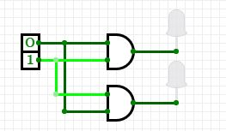
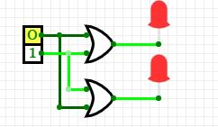

Associative Law:A. (B.C) = (A.B). C
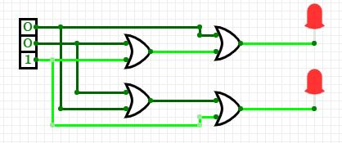
DeMorgans Law: (A.B)' = A' +B'
(A+B)' = A'.B'
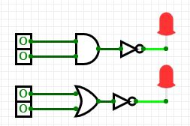
= 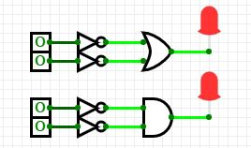

Truth Table:
Commutative Law:
A | B | AB | BA
0 | 0 | 0 | 0
0 | 1 | 0 | 0
1 | 0 | 0 | 0
1 | 1 | 1 | 1

Associative Law:
A | B | C | A(BC) | (AB)C
0 | 0 | 0 | 0 | 0
0 | 0 | 1 | 0 | 0
0 | 1 | 0 | 0 | 0
0 | 1 | 1 | 0 | 0
1 | 0 | 0 | 0 | 0
1 | 0 | 1 | 0 | 0
1 | 1 | 0 | 0 | 0
1 | 1 | 1 | 1 | 1

DeMorgans Law:
A | B | (A+B)’ | A’.B’
0 | 0 | 1 | 1
0 | 1 | 0 | 0
1 | 0 | 0 | 0
1 | 1 | 0 | 0

Inference And Conclusion:
The above logic gate and its truth table and Boolean theorem were verified.

EX.NO:3
DATE :26.09.2020
IMPLEMENTATION OF BOOLEAN FUNCTIONSADDERS AND SUBTRACTORS
AIM:
To design and verify the adders and subtractors using logic gate.

COMPONENTS / EQUIPMENTS REQUIRED:
S. No | Components / Equipments | Specifications | Quantity
1 | CircuitVerse Software | --- | 1
2 | NOT, AND, OR, Ex-OR Gate | IC 7404,7408,7432,7486 | Each one
3 | Connecting wires | --- | Sufficient numbers

LOGIC DIAGRAM OF HALF ADDER: BLOCK SCHEMATIC OF HALF ADDER:
Half Adder
C=AB

S=AB

B
A

LOGIC DIAGRAM OF FULL ADDER
BLOCK DIAGRAM OF FULL ADDER
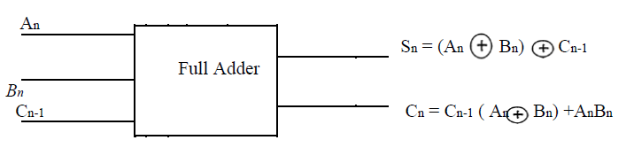

LOGIC DIAGRAM FOR HALF SUBTRACTOR

BLOCK SCHEMATIC OF HALF SUBTRACTOR:
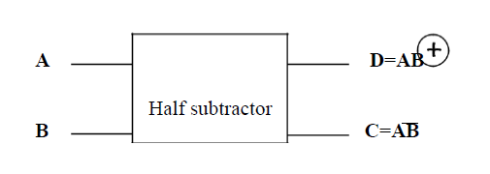

LOGIC DIAGRAM FOR FULL SUBTRACTOR:

BLOCK SCHEMATIC OF FULL SUBTRACTOR
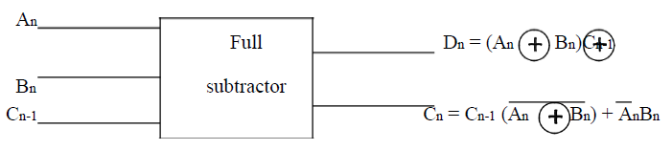

Half Adder:
Output: Truth Table:
A | B | carry | sum
0 | 0 | 0 | 0
0 | 1 | 0 | 1
1 | 0 | 0 | 1
1 | 1 | 1 | 0
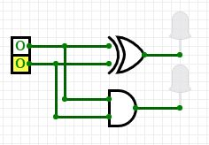

K-Map for SUM: K-Map for CARRY:
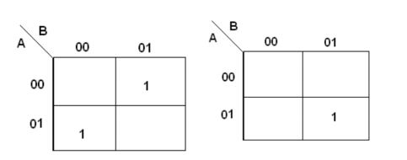
SUM = A’B + AB’ CARRY = AB

Full Adder:
Output Truth Table:
A | B | C | carry | sum
0 | 0 | 0 | 0 | 0
0 | 0 | 1 | 0 | 1
0 | 1 | 0 | 0 | 1
0 | 1 | 1 | 1 | 0
1 | 0 | 0 | 0 | 1
1 | 0 | 1 | 1 | 0
1 | 1 | 0 | 1 | 0
1 | 1 | 1 | 1 | 1
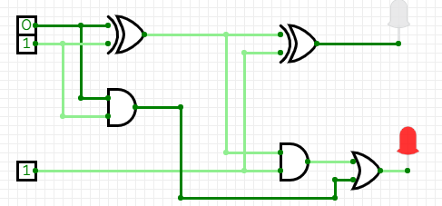

K-Map for SUM: K-Map for CARRY:
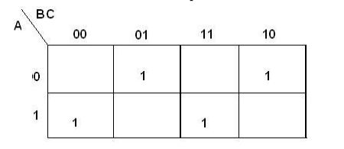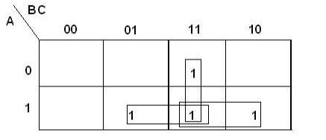
SUM = A’B’C + A’BC’ + ABC’ + ABC CARRY = AB + BC + AC

Half subtractor:
Output Truth table:
A | B | borrow | Diff
0 | 0 | 0 | 0
0 | 1 | 1 | 1
1 | 0 | 0 | 1
1 | 1 | 0 | 0
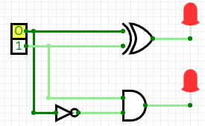

K-Map for DIFFERENCE: K-Map for BORROW:
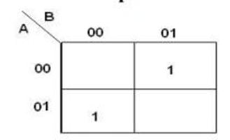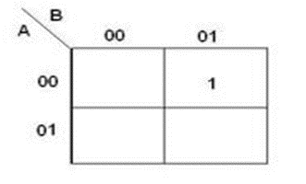
DIFFERENCE = A’B + AB’ BORROW = A’B
Full Subtractor:
Output
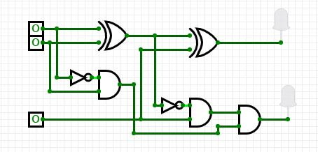

Truth table:
A | B | C | borrow | diff
0 | 0 | 0 | 0 | 0
0 | 0 | 1 | 1 | 1
0 | 1 | 0 | 1 | 1
0 | 1 | 1 | 1 | 0
1 | 0 | 0 | 0 | 1
1 | 0 | 1 | 0 | 0
1 | 1 | 0 | 0 | 0
1 | 1 | 1 | 1 | 1

K-Map for Difference: K-Map for Borrow:
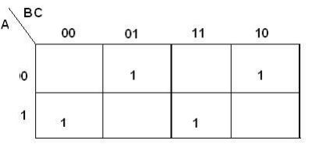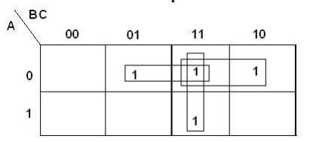
Difference = A’B’C + A’BC’ + AB’C’ + ABC Borrow = A’B + BC + A’C

PROCEDURE:
1. Give the connections as per the circuit diagram (Half Adder).
2. Switch on the trainer kit.
3. Apply the binary inputs at the appropriate terminal and observe the corresponding output.
4. Verify the truth table and repeat the above procedure for other circuits.

INFERENCE AND CONCLUSION:
Thus the adders and sub tractors were constructed using the logic gates and the truth tables were verified.
EX.NO:4
DATE :26.09.2020
DESIGN AND IMPLEMENTATION OF 4 BIT BINARY ADDER / SUBTRACTOR USING IC 7483
AIM:
To study the 4 bit binary adder/subtractor using IC7483.

COMPONENTS / EQUIPMENTS REQUIRED:
S. No. | Components / Equipments | Specification | Quantity
1. | CircuitVerse Software | --- | 1
2. | AND Gate | IC7408 | 1
3. | OR Gate | IC7432 | 1
4. | Binary Adder / Subtractor | IC 7483 | 2
5. | Connecting Wires | --- | Sufficient Numbers

Functional symbol for IC 7483:
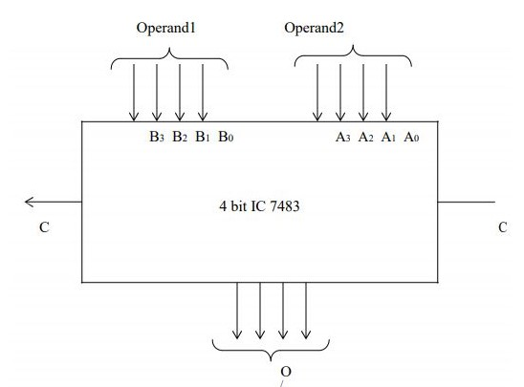
Pin Diagram of IC7483:
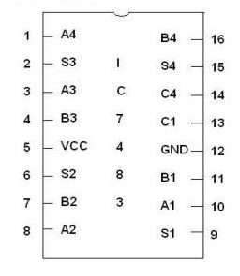
Circuit Diagram for 4-bit Binary adder/subtractor:
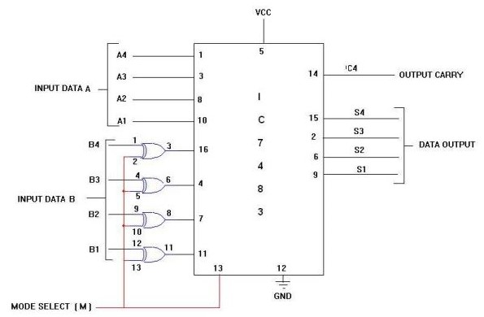
4-Bit Binary Subtractor:
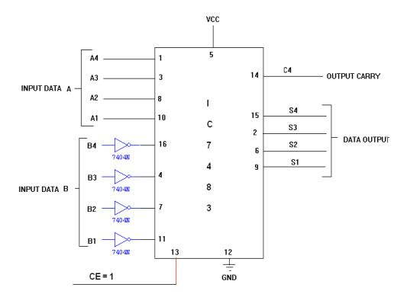

PROCEDURE:
1. Give the connections as per the circuit diagram (Half Adder).
2. Switch on the trainer kit.
3. Apply the binary inputs at the appropriate terminal and observe the corresponding output.
4. Verify the truth table and repeat the above procedure for other circuits.

INFERENCE AND CONCLUSION:
Thus the 4 bit Binary Adder / Subtractor using IC7483 is been implemented for both addition and subtraction and the corresponding truth tables are verified.

EX.NO:5
DATE :03.10.2020
DESIGN AND IMPLEMENTATION OF CODE CONVERTERS
AIM:
To design and verify the truth table of the following code converters
1. Binary to Gray converter
2. Gray to Binary converter &
3. BCD to Excess3 &
4. Excess3 to BCD.

COMPONENTS / EQUIPMENTS REQUIRED:
S. No. | Components / Equipment’s | Specifications | Quantity
1. | CircuitVerse Software |  | 1
2. | NOT, AND, OR, Ex-OR Gate | IC7404,7408,7432,7486 | 1
3. | Connecting wires |  | Sufficient numbers

CIRCUIT DIAGRAM:
Binary to GRAY
TRUTH TABLE FOR BINARY TO GRAY CODE CONVERTER:
Binary input |  |  |  | Gray code output
B3 | B2 | B1 | B0 | G3 | G2 | G1 | G0
0 | 0 | 0 | 0 | 0 | 0 | 0 | 0
0 | 0 | 0 | 1 | 0 | 0 | 0 | 1
0 | 0 | 1 | 0 | 0 | 0 | 1 | 1
0 | 0 | 1 | 1 | 0 | 0 | 1 | 0
0 | 1 | 0 | 0 | 0 | 1 | 1 | 0
0 | 1 | 0 | 1 | 0 | 1 | 1 | 1
0 | 1 | 1 | 0 | 0 | 1 | 0 | 1
0 | 1 | 1 | 1 | 0 | 1 | 0 | 0
1 | 0 | 0 | 0 | 1 | 1 | 0 | 0
1 | 0 | 0 | 1 | 1 | 1 | 0 | 1
1 | 0 | 1 | 0 | 1 | 1 | 1 | 1
1 | 0 | 1 | 1 | 1 | 1 | 1 | 0
1 | 1 | 0 | 0 | 1 | 0 | 1 | 0
1 | 1 | 0 | 1 | 1 | 0 | 1 | 1
1 | 1 | 1 | 0 | 1 | 0 | 0 | 1
1 | 1 | 1 | 1 | 1 | 0 | 0 | 0

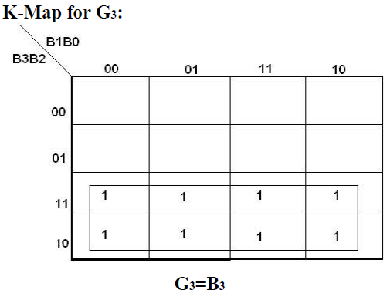
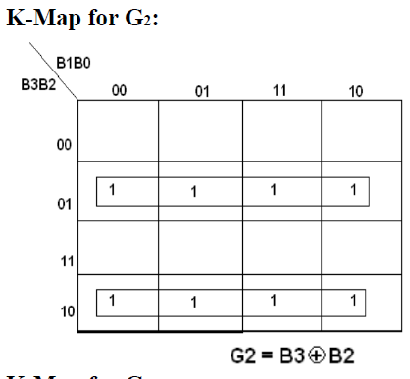

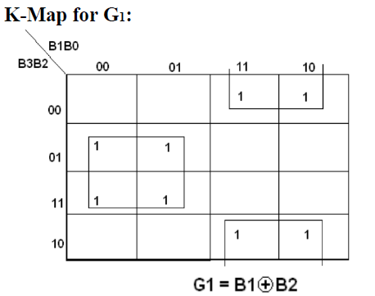
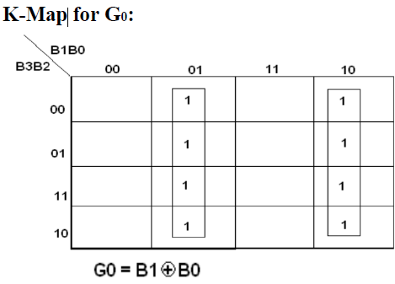

GRAY to Binary

TRUTH TABLE FOR GRAY CODE TO BINARY CONVERTOR:
Gray Code |  |  |  | Binary Code
G3 | G2 | G1 | G0 | B3 | B2 | B1 | B0
0 | 0 | 0 | 0 | 0 | 0 | 0 | 0
0 | 0 | 0 | 1 | 0 | 0 | 0 | 1
0 | 0 | 1 | 1 | 0 | 0 | 1 | 0
0 | 0 | 1 | 0 | 0 | 0 | 1 | 1
0 | 1 | 1 | 0 | 0 | 1 | 0 | 0
0 | 1 | 1 | 1 | 0 | 1 | 0 | 1
0 | 1 | 0 | 1 | 0 | 1 | 1 | 0
0 | 1 | 0 | 0 | 0 | 1 | 1 | 1
1 | 1 | 0 | 0 | 1 | 0 | 0 | 0
1 | 1 | 0 | 1 | 1 | 0 | 0 | 1
1 | 1 | 1 | 1 | 1 | 0 | 1 | 0
1 | 1 | 1 | 0 | 1 | 0 | 1 | 1
1 | 0 | 1 | 0 | 1 | 1 | 0 | 0
1 | 0 | 1 | 1 | 1 | 1 | 0 | 1
1 | 0 | 0 | 1 | 1 | 1 | 1 | 0
1 | 0 | 0 | 0 | 1 | 1 | 1 | 1

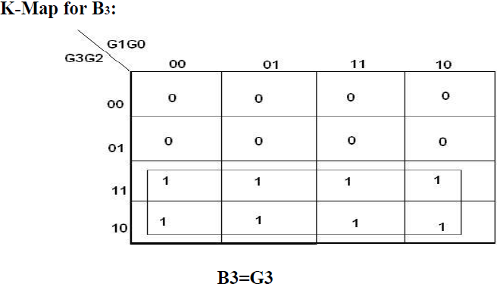
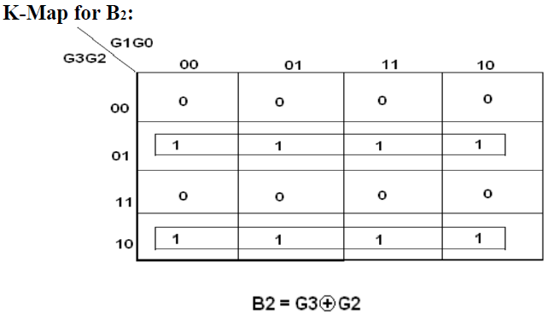

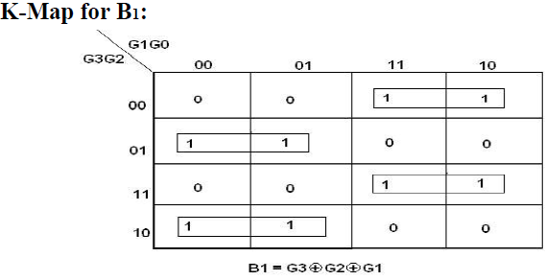

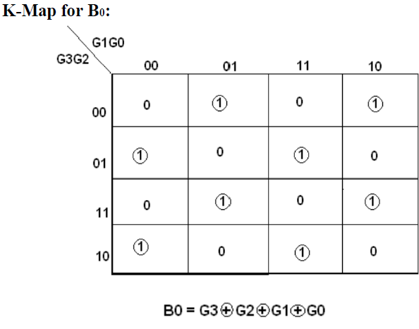
LOGIC DIAGRAM:
BCD TO EXCESS-3 CONVERTOR
TRUTH TABLE FOR BCD TO EXCESS-3 CONVERTOR:
BCD input |  |  |  | Excess – 3 output
B3 | B2 | B1 | B0 | G3 | G2 | G1 | G0
0 | 0 | 0 | 0 | 0 | 0 | 1 | 1
0 | 0 | 0 | 1 | 0 | 1 | 0 | 0
0 | 0 | 1 | 0 | 0 | 1 | 0 | 1
0 | 0 | 1 | 1 | 0 | 1 | 1 | 0
0 | 1 | 0 | 0 | 0 | 1 | 1 | 1
0 | 1 | 0 | 1 | 1 | 0 | 0 | 0
0 | 1 | 1 | 0 | 1 | 0 | 0 | 1
0 | 1 | 1 | 1 | 1 | 0 | 1 | 0
1 | 0 | 0 | 0 | 1 | 0 | 1 | 1
1 | 0 | 0 | 1 | 1 | 1 | 0 | 0
1 | 0 | 1 | 0 | x | x | x | x
1 | 0 | 1 | 1 | x | x | x | x
1 | 1 | 0 | 0 | x | x | x | x
1 | 1 | 0 | 1 | x | x | x | x
1 | 1 | 1 | 0 | x | x | x | x
1 | 1 | 1 | 1 | x | x | x | x

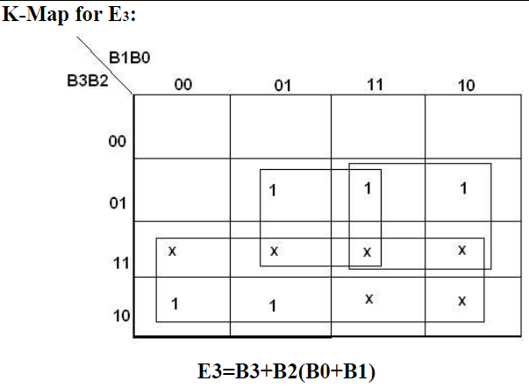
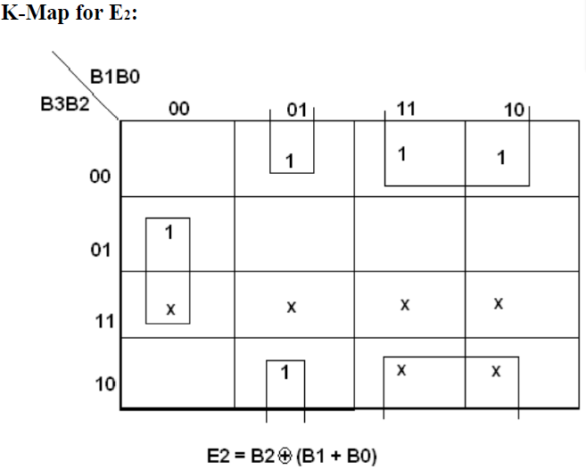

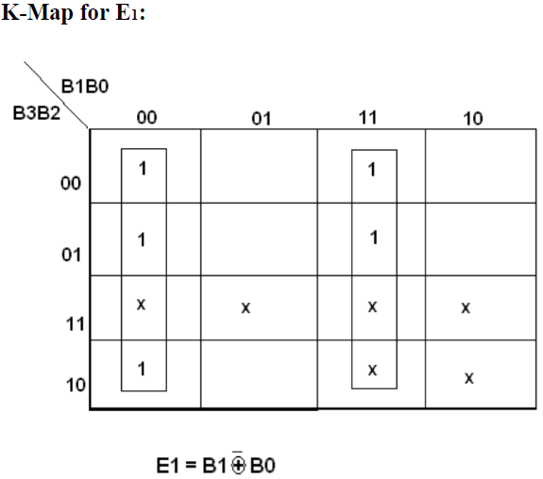

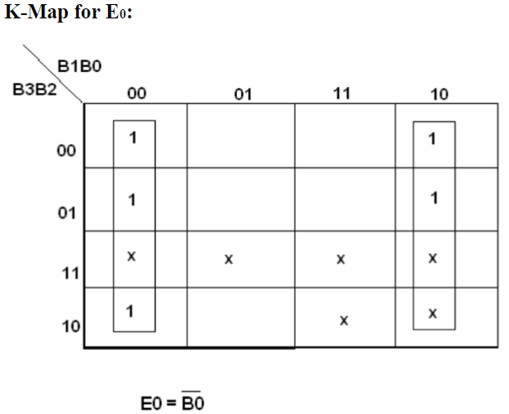
LOGIC DIAGRAM:
EXCESS-3 TO BCD CONVERTOR
TRUTH TABLE FOR EXCESS-3 TO BCD CONVERTOR:
Excess – 3 Input |  |  |  | BCD Output
B3 | B2 | B1 | B0 | G3 | G2 | G1 | G0
0 | 0 | 1 | 1 | 0 | 0 | 0 | 0
0 | 1 | 0 | 0 | 0 | 0 | 0 | 1
0 | 1 | 0 | 1 | 0 | 0 | 1 | 0
0 | 1 | 1 | 0 | 0 | 0 | 1 | 1
0 | 1 | 1 | 1 | 0 | 1 | 0 | 0
1 | 0 | 0 | 0 | 0 | 1 | 0 | 1
1 | 0 | 0 | 1 | 0 | 1 | 1 | 0
1 | 0 | 1 | 0 | 0 | 1 | 1 | 1
1 | 0 | 1 | 1 | 1 | 0 | 0 | 0
1 | 1 | 0 | 0 | 1 | 0 | 0 | 1

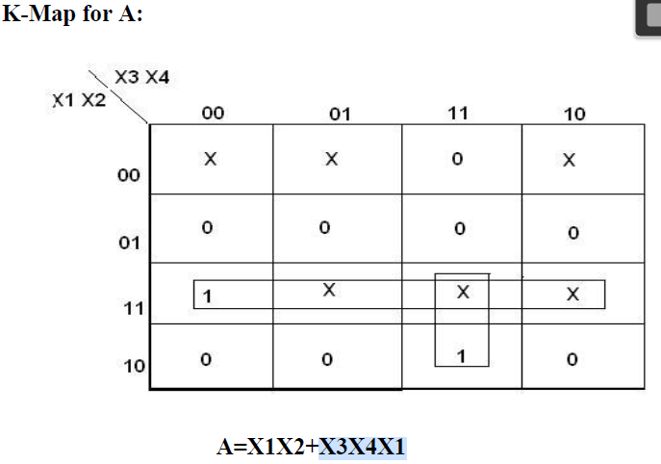

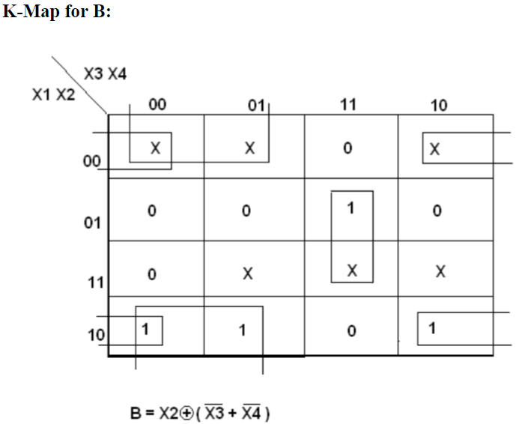

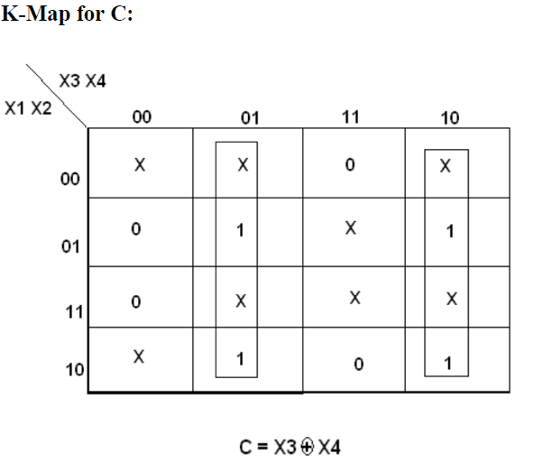

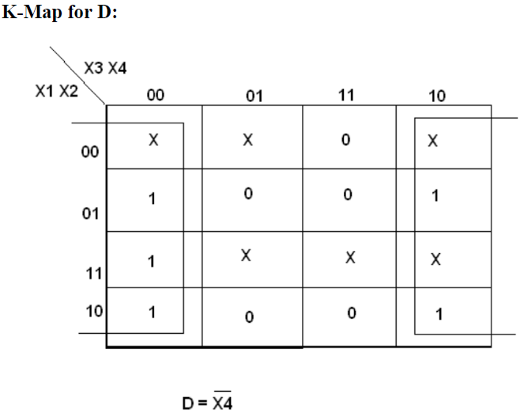
OUTPUT:
Binary to Gray Gray to Binary
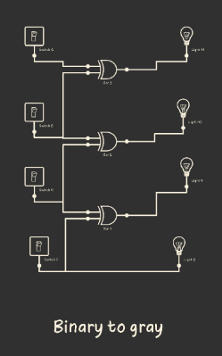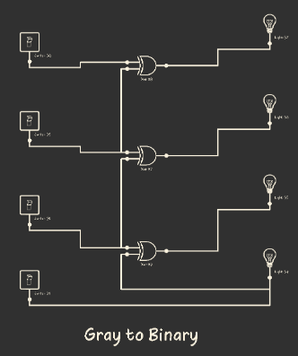

BCD to Excess 3 Excess 3 to BCD
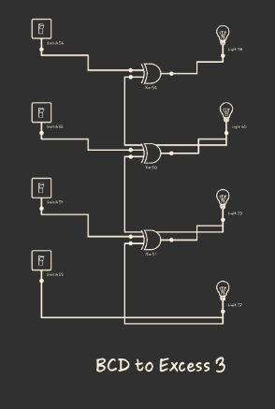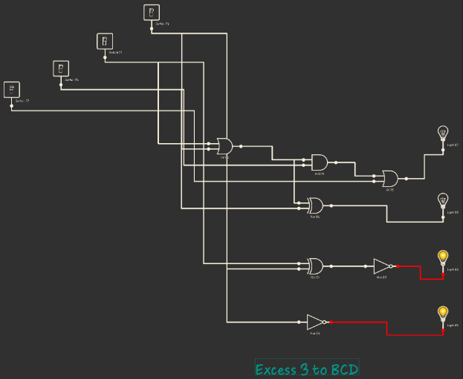
PROCEDURE:

1. Connections are given as per the circuit diagram (Binary to GRAY).
2. Switch on the power supply.
3. Verify the truth table given for different inputs.
4. Repeat the above procedures for other converters.

INFERENCE AND CONCLUSION:
Thus the truth tables for Binary to Gray, Gray to Binary and BCD to Excess3 converters were verified.

EX.NO:6
DATE :10.10.2020
IMPLEMENTATION OF AN ARBITRARY FUNCTIONS USING
LOGIC GATES
AIM:
To Implement the given Arbitrary Functions by using logic gates.
COMPONENTS / EQUIPMENTS REQUIRED:
S.No. | Name of the apparatus | Specifications | Quantity
1 | CircuitVerse Software | - | 1
2 | NOR gate | IC 7402 | 2
3 | AND gate | IC 7408 | 2
4 | NOT gate | IC 7404 | 1
5 | Ex-OR gate | IC 7486 | 1
6 | Connecting wires | - | some

Truth Table:
Inputs |  |  |  | Outputs
A1 | A0 | B1 | B0 | A<B | A=B | A>B
0 | 0 | 0 | 0 | 0 | 1 | 0
0 | 0 | 0 | 1 | 1 | 0 | 0
0 | 0 | 1 | 0 | 1 | 0 | 0
0 | 0 | 1 | 1 | 1 | 0 | 0
0 | 1 | 0 | 0 | 0 | 0 | 1
0 | 1 | 0 | 1 | 0 | 1 | 0
0 | 1 | 1 | 0 | 1 | 0 | 0
0 | 1 | 1 | 1 | 1 | 0 | 0
1 | 0 | 0 | 0 | 0 | 0 | 1
1 | 0 | 0 | 1 | 0 | 0 | 1
1 | 0 | 1 | 0 | 0 | 1 | 0
1 | 0 | 1 | 1 | 1 | 0 | 0
1 | 1 | 0 | 0 | 0 | 0 | 1
1 | 1 | 0 | 1 | 0 | 0 | 1
1 | 1 | 1 | 0 | 0 | 0 | 1
1 | 1 | 1 | 1 | 0 | 1 | 0

LOGIC DIAGRAM:
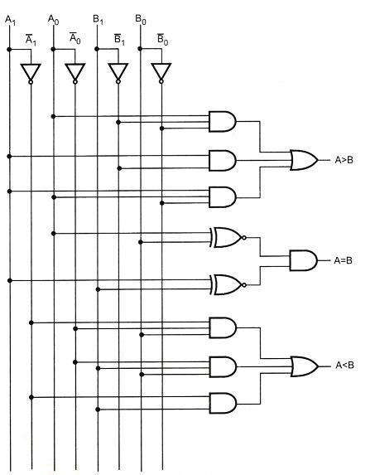

CIRCUIT DIAGRAM:
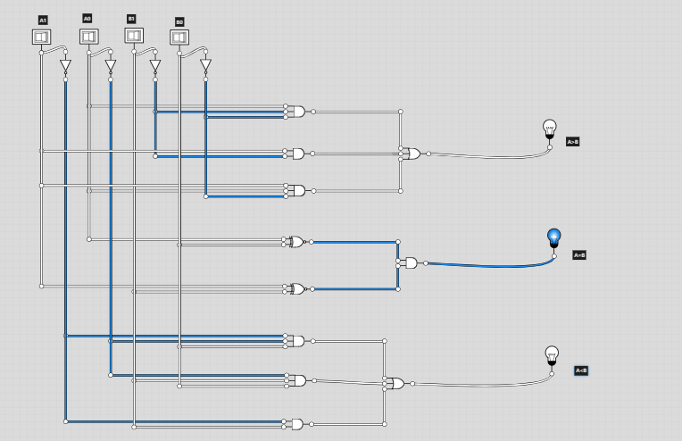

PROCEDURE:
1. Connections are given as per in the circuit diagram.
2. Inputs are given through the logic switches.
3. Outputs are noted and verified with truth table.

Inference And Conclusion:
Thus the given functions are implemented and their truth table were verified using logic gates.
EX.NO:7
DATE:10.10.2020
IMPLEMENTATION OF AN ARBITRARY FUNCTIONS
USING LOGIC GATES
AIM:
To design and implement 8 – bit magnitude comparator using IC 7485.

COMPONENTS / EQUIPMENTS REQUIRED:
S.No: | Component | Specification | Qty.
1. | And Gate | IC 7408 | 2
2. | X-Or Gate | IC 7486 | 1
3. | Or Gate | IC 7432 | 1
4. | Not Gate | IC 7404 | 1
5. | 4-Bit MagnitudeComparator | IC 7485 | 2
6. | Ic Trainer Kit | - | 1
7. | Patch Cords | - | 30

PIN DIAGRAM FOR IC 7485:
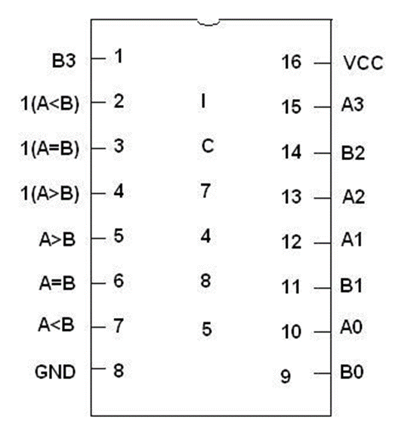
8 Bit Magnitude Comparator:
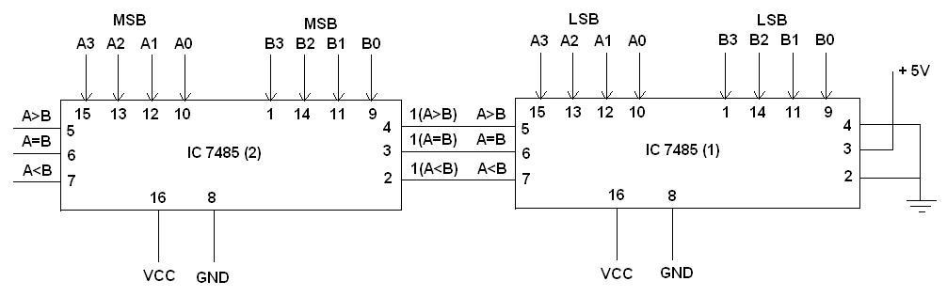

TRUTH TABLE FOR 8 BIT MAGNITUDE COMPARATOR:
 | A | B | A>B | A=B | A<B
0000 | 0000 | 0000 0000 | 0 | 1 | 0
0001 | 0001 | 0000 0000 | 1 | 0 | 0
0000 | 0000 | 0001 0001 | 0 | 0

PROCEDURE:
1. Connections are given as per in the circuit diagram.
2. Inputs are given through the logic switches.
3. Outputs are noted and verified with truth table.

INFERENCE AND CONCLUSION:
Thus the 2-bit magnitude comparator was designed and its truth table was verified using logic gates.
EXP.NO:8
DATE :21.10.2020
DESIGN AND IMPLEMENTATION OF 16-BIT ODD /
EVEN PARITY GENERATOR & CHECKER
AIM:
To design and implement 16 bit odd/even parity checker generator using IC 74180.
COMPONENTS / EQUIPMENTS REQUIRED:

S.No | COMPONENT | SPECIFICATION | QTY.
1. | NOT GATE | IC 7404 | 1
2. | PARITY GENERATOR/CHECKER IC | IC 74180 | 2
3. | IC TRAINER KIT | - | 1
4. | PATCH CORDS | - | 30

LOGIC DIAGRAM:
16 bit odd/even parity checker
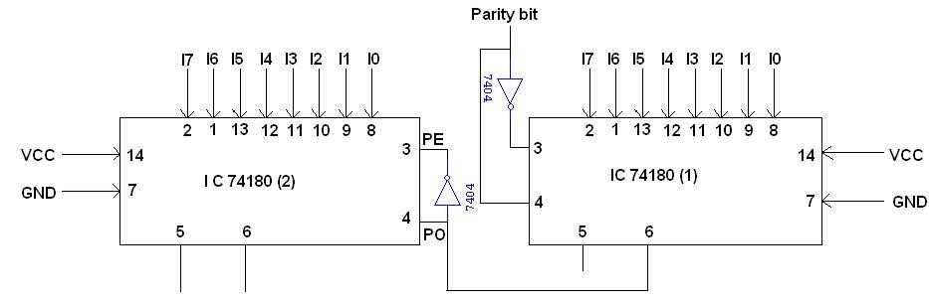
TRUTH TABLE FOR 16 BIT ODD/EVEN PARITY CHECKER:

I7 I6 I5 I4 I3 I2 I1 I0 | I7’I6’I5’I4’I3’I2’11’ I0’ | Active | ∑E | ∑O
0 0 0 0 0 0 01 | 0 0 0 0 0 0 0 0 | 1 | 1 | 0
0 0 0 0 0 1 10 | 0 0 0 0 0 1 1 0 | 0 | 1 | 0
0 0 0 0 0 1 10 | 0 0 0 0 0 1 1 0 | 1 | 0 | 1

LOGIC DIAGRAM:
16 bit odd/even parity generator

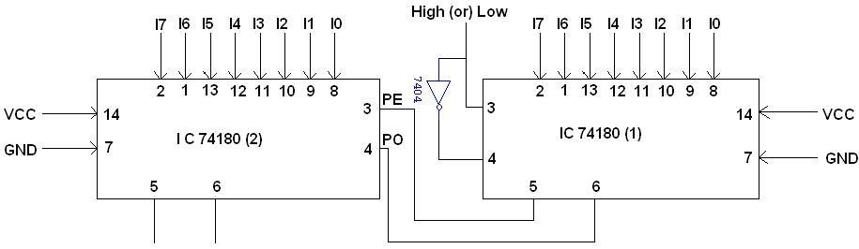

TRUTH TABLE 16 BIT ODD/EVEN PARITY GENERATOR:
I7 I6 I5 I4 I3 I2 I1 I0 | I7 I6 I5 I4 I3 I2 I1 I0 | Active | ∑E | ∑O
1 1 0 0 0 0 0 0 | 1 1 0 0 0 0 0 0 | 1 | 1 | 0
1 1 0 0 0 0 0 0 | 1 1 0 0 0 0 0 0 | 0 | 0 | 1
1 1 0 0 0 0 0 0 | 0 1 0 0 0 0 0 0 | 0 | 1 | 0

FUNCTION TABLE:
INPUTS |  |  | OUTPUTS
Number of High  Data of Inputs (I0 – I7) | PE | PO | ∑E | ∑O
EVEN | 1 | 0 | 1 | 0
ODD | 1 | 0 | 0 | 1
EVEN | 0 | 1 | 0 | 1
ODD | 0 | 1 | 1 | 0
X | 1 | 1 | 0 | 0
X | 0 | 0 | 1 | 1

PROCEDURE:
- Connections are given as per the circuit diagram.
- Switch on the power supply.
- Verify the truth table given for different inputs.
- Repeat the above procedures for even parity checker.

INFERENCE AND CONCLUSION:
Thus 16- bit Even Parity Generator and 16- bit Even parity checker were constructed and tested.

EX.NO:9
DATE:21.10.2020
IMPLEMENTATION OF FULL ADDER USING MULTIPLEXER
AIM:
To design and construct full adder circuit and verify the truth table using multiplexers.

COMPONENTS / EQUIPMENTS REQUIRED:
S.No. | COMPONENT | SPECIFICATION | QTY.
1. | MUX IC | IC 74151 | 2
2. | NOT GATE | IC 7404 | 1
3. | IC TRAINER KIT | - | 1
4. | PATCH CORDS | - | 32

LOGIC DIAGRAM: For Sum Bit Of Full Adder Using 4:1 Multiplexer
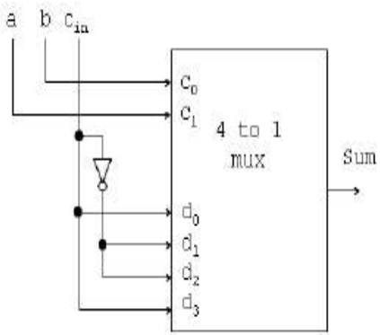
OUTPUT:
Sum Bit Of Full Adder Using 4:1 Multiplexer:

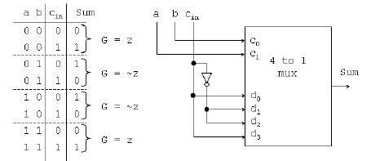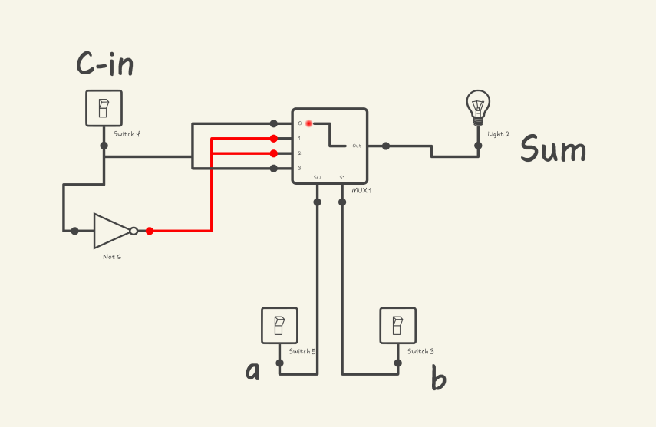

Carry Bit Of Full Adder Using 4:1 Multiplexer:
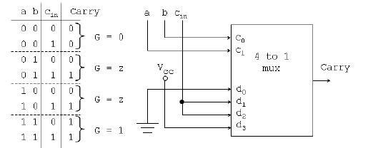

Pin Diagram:
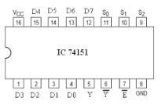
PROCEDURE:
1. Connections are given as per circuit diagram.
2. Logical inputs are given as per circuit diagram.
3. Observe the output and verify the truth table.

INFERENCE AND CONCLUSION:
Thus the full adder using multiplexer were constructed and their truth table was verified.

EX.NO:10
DATE:22.10.2020
IMPLEMENTATION OF SISO, SIPO, PISO AND PIPO, SHIFT REGISTERS
AIM:
To implement the 4-bit shift register using flip flops and to study the operations in the following modes.
- Serial in serial out
- Serial in parallel out
- Parallel in parallel out
- Parallel in serial out

COMPONENTS / EQUIPMENTS REQUIRED:
S.NO | Name of the apparatus | Range | Quantity
1 | CircuitVerse Software
2 | D Flip Flop | IC 7474 | 2
3 | Connecting wires |  | some

PIN DIAGRAM:
LOGIC DIAGRAM:
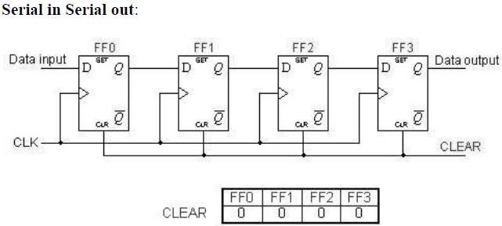
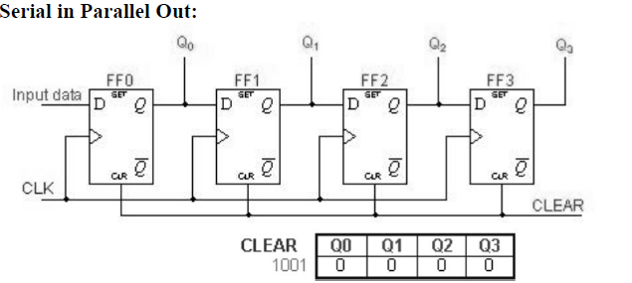
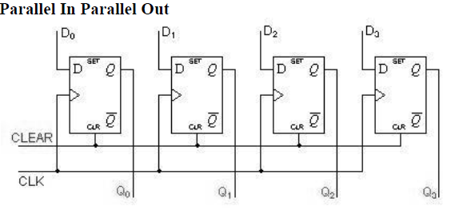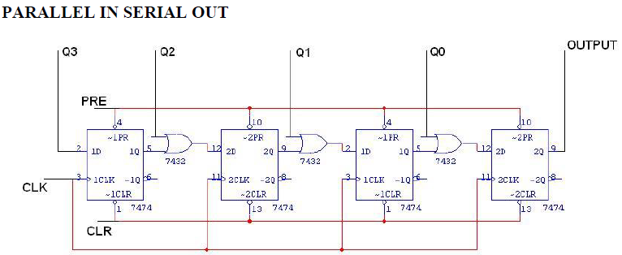

OUTPUT:
Serial in Serial out:
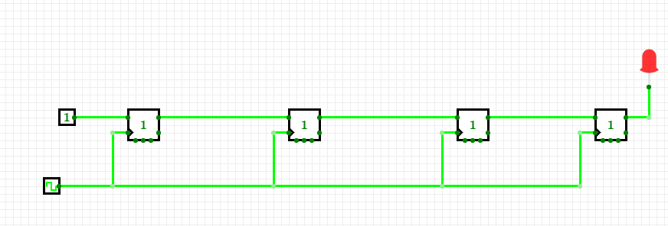

Serial in Parallel Out:
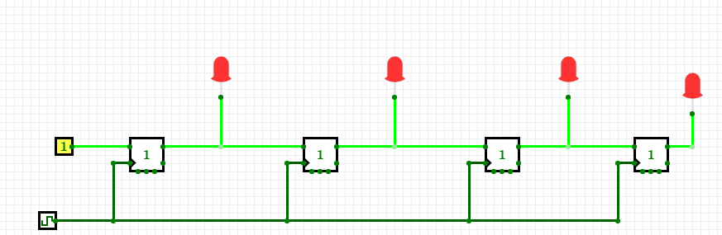

Parallel In Parallel Out:

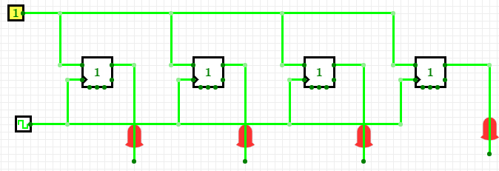

Parallel In Serial Out:

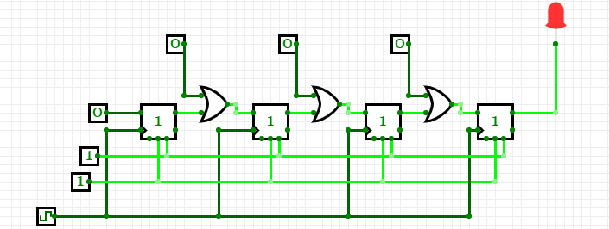

TRUTH TABLE FOR PISO SHIFT REGISTER:

CLK | Q3 | Q2 | Q1 | Q0 | O/P
0 | 1 | 0 | 0 | 1 | 1
1 | 0 | 0 | 0 | 0 | 0
2 | 0 | 0 | 0 | 0 | 0
3 | 0 | 0 | 0 | 0 | 1

PROCEDURE:

1. The flip-flop is connected using connecting wires as shown in the circuit.
2. The flip flop are then reset to zero internally with the help of reset to set inputs.
3. The bits are shifted in by giving suitable clock input.
4. Thus the truth table is then verified.

INFERENCE AND CONCLUSION:
Thus the operation of 4 bit shift register for SISO, SIPO, and PIPO was studied and verified.

EX.NO:11
DATE:22.10.2020
DESIGN AND IMPLEMENTATION OF 4 BITSYNCHRONOUS
JOHNSON COUNTER
AIM:
To design and implementation of 4-bit synchronous Johnson counter using D flip flop.

COMPONENTS / EQUIPMENTS REQUIRED:
S. No. | Name of the apparatus | Range | Quantity
1 | CircuitVerse Software |  | 1
2 | D Flip Flop | IC 7474 | 2
3 | Connecting wire |  | some

CIRCUIT DIAGRAM:
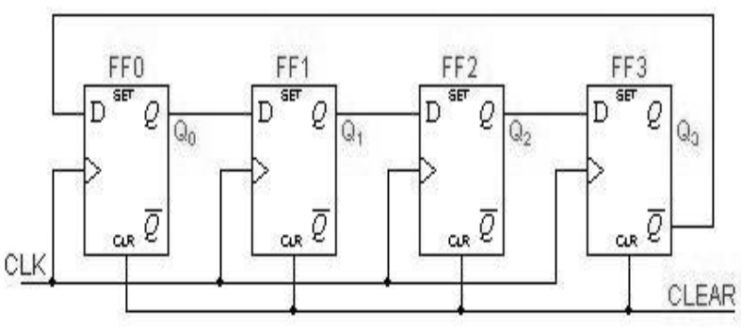

OUTPUT:
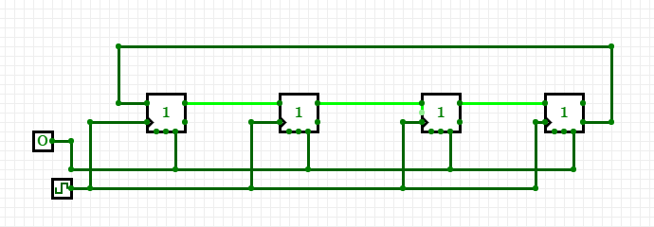

TRUTH TABLE:
Clock Pulse | Q3 | Q2 | Q1 | Q0
0 | 0 | 0 | 0 | 0
1 | 0 | 0 | 0 | 1
2 | 0 | 0 | 1 | 1
3 | 0 | 1 | 1 | 1
4 | 1 | 1 | 1 | 1
5 | 1 | 1 | 1 | 0
6 | 1 | 1 | 0 | 0
7 | 1 | 0 | 0 | 0
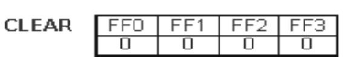

PROCEDURE:
1. Connections are made as per circuit diagram.
2. Clock pulses are applied one by one at the clock I/P and the O/P is observed at QA, QB & QC for IC 7476.
3. Verify the Truth table.

INFERENCE:
Thus the operation of 4 bit synchronous Johnson counter using D flip flop was studied and verified.
EX.NO:12
DATE:23.10.2020
DESIGN AND IMPLEMENTATION OFSYNCHRONOUS COUNTER

AIM:
To construct and verify the synchronous up/down counters.

COMPONENTS / EQUIPMENTS REQUIRED:
S. No. | Name of the apparatus | Range | Quantity
1 | CircuitVerse Software |  | 1
2 | JK Flip-Flop, AND Gate | IC 7473,7408 | 2,1
3 | Connecting wire |  | some

CIRCUIT DIAGRAM: DESIGN OF 3-BIT SYNCHRONOUS UP:
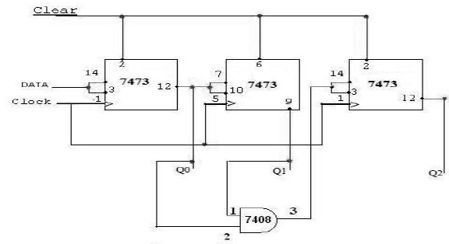

CIRCUIT DIAGRAM: DESIGN OF 3-BIT SYNCHRONOUS DOWN:
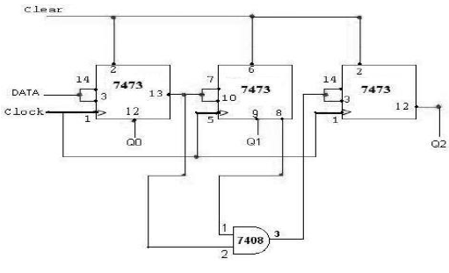

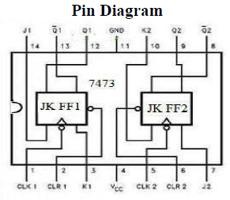

OUTPUT:DESIGN OF 3-BIT SYNCHRONOUS UP:
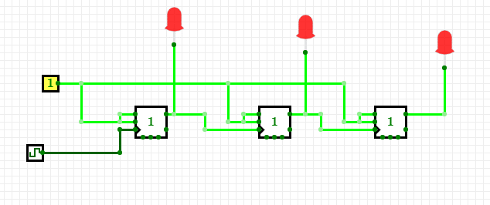

DESIGN OF 3-BIT SYNCHRONOUS DOWN COUNTER:
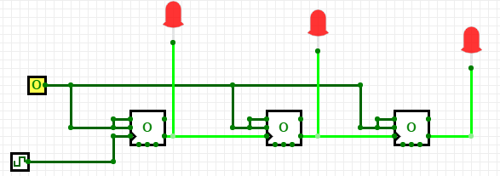
TRUTH TABLE:
3 Bit Synchronous UP Counter |  |  |  | 3 Bit Synchronous DOWNCounter
Clock | Q2 | Q1 | Q0 | Clock | Q2 | Q1 | Q0
0 | 0 | 0 | 0 | 0 | 1 | 1 | 1
1 | 0 | 0 | 1 | 1 | 1 | 1 | 0
2 | 0 | 1 | 0 | 2 | 1 | 0 | 1
3 | 0 | 1 | 1 | 3 | 1 | 0 | 0
4 | 1 | 0 | 0 | 4 | 0 | 1 | 1
5 | 1 | 0 | 1 | 5 | 0 | 1 | 0
6 | 1 | 1 | 0 | 6 | 0 | 0 | 1
7 | 1 | 1 | 1 | 7 | 0 | 0 | 0

PROCEDURE:
1. The connections are made as per the circuit diagram.
2. Switch on the power supply.
3. The input is given at the appropriate terminal and corresponding output is observed and truth table is verified.

INFERENCE:
Thus the counters were constructed and their truth tables verified.
EX.NO:13
DATE:23.10.2020
DESIGN AND IMPLEMENTATION OF ASYNCHRONOUS COUNTER
AIM:
To construct and verify the asynchronous counters.

COMPONENTS / EQUIPMENTS REQUIRED:
S. No. | Name of the apparatus | Range | Quantity
1 | CircuitVerse Software |  | 1
2 | JK Flip-Flop, | IC 7473 | 2
3 | NAND, AND Gate | IC 7400, 7408 | Each 1
4 | Connecting wire |  | Some

CIRCUIT DIAGRAM:
ASYNCHRONOUS COUNTER: - MOD 16 COUNTER

MOD 12 COUNTERS:
MOD 10 COUNTERS

OUTPUT:
Asynchronous Counter: - Mod 16 Counter
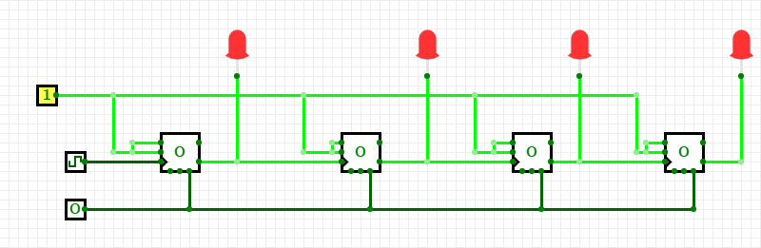
Mod 12 Counters:
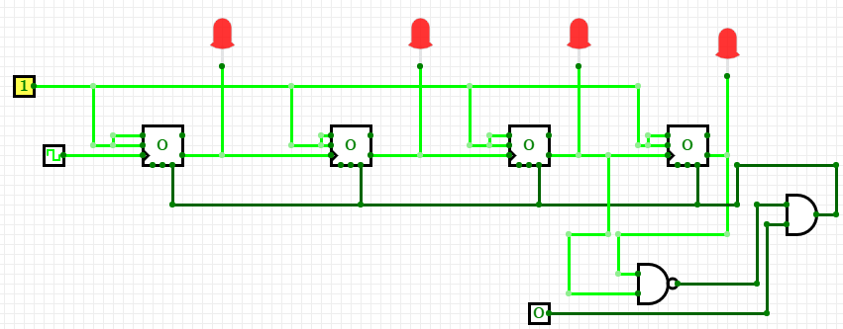

Mod 10 Counters:
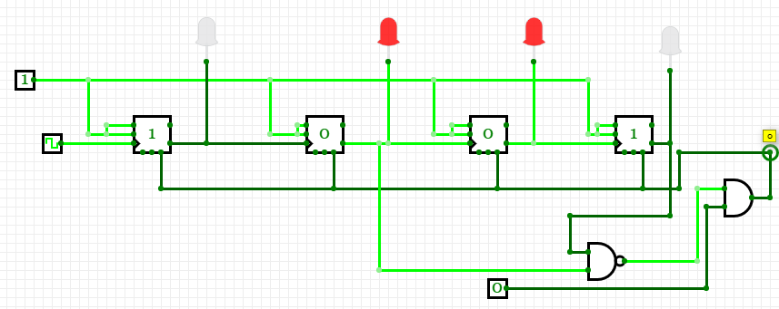

TRUTH TABLE:
MOD 16 Counter
Clock | Q0 | Q1 | Q2 | Q3
0 | 0 | 0 | 0 | 0
1 | 0 | 0 | 0 | 1
2 | 0 | 0 | 1 | 0
3 | 0 | 0 | 1 | 1
4 | 0 | 1 | 0 | 0
5 | 0 | 1 | 0 | 1
6 | 0 | 1 | 1 | 0
7 | 0 | 1 | 1 | 1
8 | 1 | 0 | 0 | 0
9 | 1 | 0 | 0 | 1
10 | 1 | 0 | 1 | 0
11 | 1 | 0 | 1 | 1
12 | 1 | 1 | 0 | 0
13 | 1 | 1 | 0 | 1
14 | 1 | 1 | 1 | 0
15 | 1 | 1 | 1 | 1
16 | 0 | 0 | 0 | 0

MOD 12 Counter
Clock | Q0 | Q1 | Q2 | Q3
0 | 0 | 0 | 0 | 0
1 | 0 | 0 | 0 | 1
2 | 0 | 0 | 1 | 0
3 | 0 | 0 | 1 | 1
4 | 0 | 1 | 0 | 0
5 | 0 | 1 | 0 | 1
6 | 0 | 1 | 1 | 0
7 | 0 | 1 | 1 | 1
8 | 1 | 0 | 0 | 0
9 | 1 | 0 | 0 | 1
10 | 1 | 0 | 1 | 0
11 | 1 | 0 | 1 | 1
12 | 0 | 0 | 0 | 0

MOD 10 Counter
Clock | Q0 | Q1 | Q2 | Q3
0 | 0 | 0 | 0 | 0
1 | 0 | 0 | 0 | 1
2 | 0 | 0 | 1 | 0
3 | 0 | 0 | 1 | 1
4 | 0 | 1 | 0 | 0
5 | 0 | 1 | 0 | 1
6 | 0 | 1 | 1 | 0
7 | 0 | 1 | 1 | 1
8 | 1 | 0 | 0 | 0
9 | 1 | 0 | 0 | 1
10 | 0 | 0 | 0 | 0

PROCEDURE:
1. The connections are made as per the circuit diagram.
2. Switch on the power supply.
3. The input is given at the appropriate terminal and corresponding output is observed and truth table is verified.

INFERENCE:
Thus the Asynchronous counters were constructed and their truth tables verified.
EX.NO:14
DATE :
HDL CODING FOR COMBINATIONAL ANDSEQUENTIAL CIRCUITS

AIM:
To write an HDL program for combinational circuits.

COMPONENTS / EQUIPMENTS REQUIRED:
1. PC
2. VHDL simulation Software

PROGRAM:
HALF ADDER:

module ha(s,co,a,b);
output s,co;
input a,b;
xor1 u1(s,a,b);
and1 u2 (co,a,b);
endmodule

FULL ADDER:

module fa(s,co,a,b,ci);
output s,co;
input a,b,ci;
xor1 u1(s,a,b,ci);
and1 u2(n1,a,b);
and1 u3(n2,b,ci);
and1 u4(n3,a,ci);
or1 u5(co,n1,n2,n3);
endmodule

HALF SUBTRACTOR:

module hs(diff,borrow,a,b);
output diff,borrow;
input a,b;
wire anot;
xor1 u1(diff,a,b);
not1 u2(anot,a);
and1 u3(borrow,anot,b);
endmodule

FULL SUBTRACTOR:-
module fs(diff,borrow,a,b,ci);
output diff,borrow;
input a,b,ci;
wire anot,n1,n2,n3,n4;
xor1 u1(n1,a,b);
xor2 u2(diff, n1,ci);
not1 u3(anot,a);
and1 u4(n2,anot,b);
not2 u5(n3,n1);
and2 u6(n4,n3,ci);
or1 u7(borrow,n2,n4);
endmodule

MULTIPLEXER:
module multiplexer(d,so,s1,y);
Input[0:3]d, s0, s1;
Output y;
Wire s0bar, s1bar, e, f, g, h;
not u1 (s0bar,s0);
not u2 (s1bar,s1);
and a1 (e,D[0],s1bar,s0bar),
and a2 (f, D [1], s1bar, s0),
and a3 (g, D [2], s1, s0bar),
and a4 (h, D [3], s1, s0),
or o(y,e,f,g,h);
endmodule

DEMULTIPLEXER:
module demultiplexer(d,so,s1,input);
Input s0, s1, input;
Output [0:3]d;
Wire s0bar, s1bar;
not u1 (s0bar,s0);
not u2 (s1bar,s1);
and a1 (D[0],input,s1bar,s0bar),
and a2 (D [1], input,s1bar, s0),
and a3 (D [2], input,s1, s0bar),
and a4 (D [3], input,s1, s0),
endmodule

SERIAL IN SERIAL OUT:
module siso (din, clk, rst, dout);
input din, clk, rst;
output dout;
reg dout;
reg [7:0]x;
always@(posedge(clk) or posedge(rst))
begin
if (rst==1’b1)
begin
dout=8’hzz;
end
else
begin
x={x[6:0],din};
dout=x[7];
end
end
endmodule

SERIAL IN PARALLEL OUT:
module sipo (din, clk, rst, dout);
input din, clk, rst;
output [7:0]dout;
reg [7:0]dout;
reg [7:0]x;
always@(posedge(clk) or posedge(rst))
begin
if (rst)
dout=8’hzz;
else
begin
x={x[6:0],din};
dout=x;
end
end
endmodule

PARALLEL IN SERIAL OUT:
module piso (din, clk, rst, load, dout);
input [7:0]din, clk, rst, load;
output dout;
reg dout;
reg [8:0]x;
always@(posedge(clk) or posedge(rst))
begin’if (rst==1’b1)
begin
dout=1’bz;
end
else
begin
if (load==1’b0)
begin
x=din;
end
else
x={x[7:0],1’hz};
dout=x[8];
end
end
endmodule

PARALLEL IN PARALLEL OUT:
module pipo (din, clk, rst, dout);
input clk, rst, [7:0]din;
output [7:0]dout;
reg [7:0]dout;
always@(posedge(clk) or posedge(rst))
begin
if (rst==1’b1)
begin
dout=8’hzz;
end
else
begin
dout=din;
end
end
endmodule

LOGIC DIAGRAM:
Half Adder
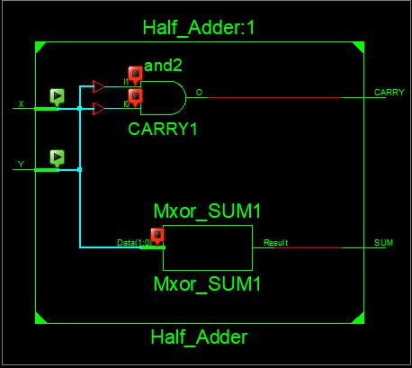
TIMING DIAGRAM:
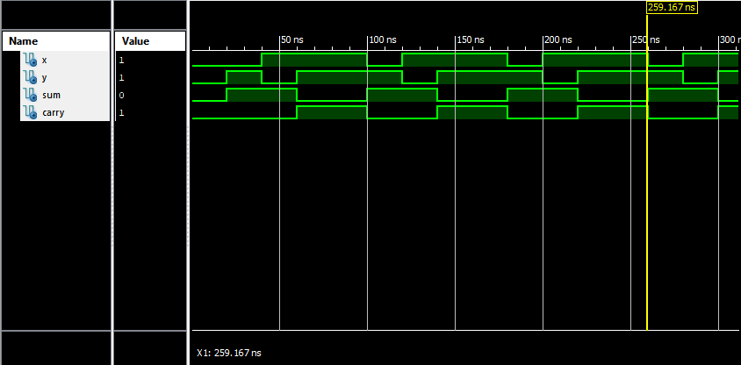
LOGIC DIAGRAM:
Full Adder
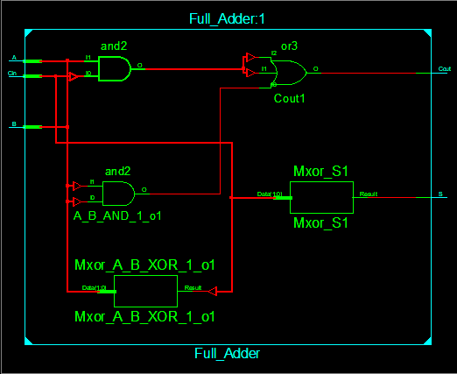
TIMING DIAGRAM:
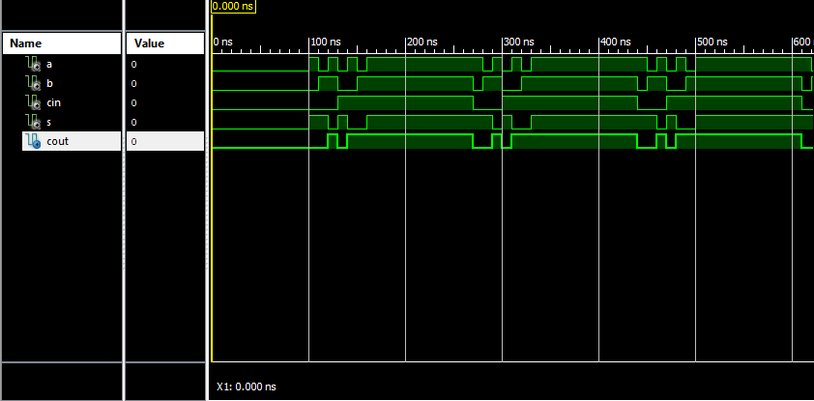
LOGIC DIAGRAM:
HALF SUBTRACTOR
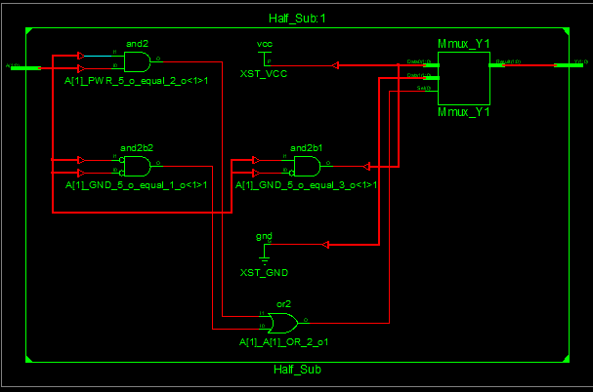

TIMING DIAGRAM:
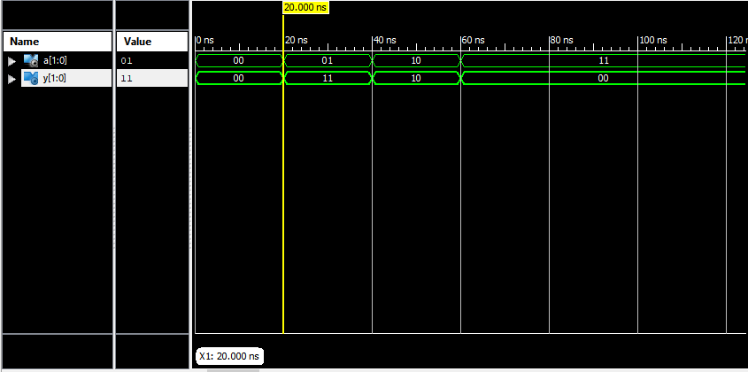
LOGIC DIAGRAM:
FULL SUBTRACTOR
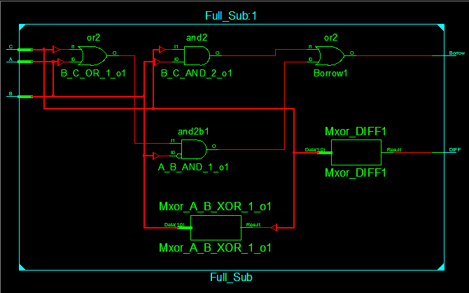
TIMING DIAGRAM:
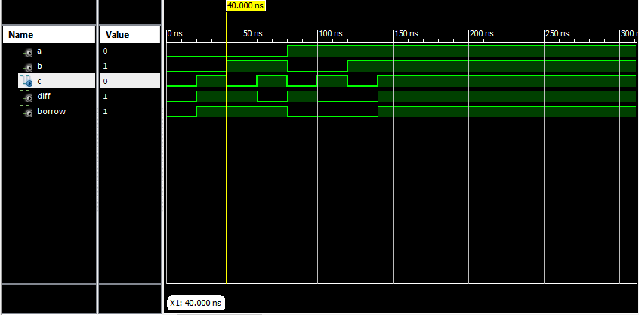

LOGIC DIAGRAM:
Multiplexer
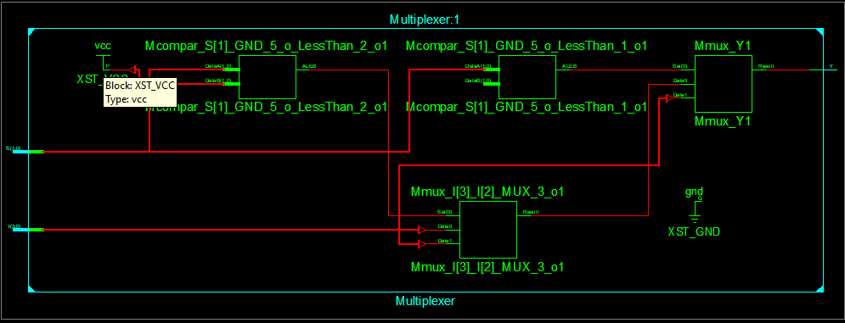

TIMING DIAGRAM:
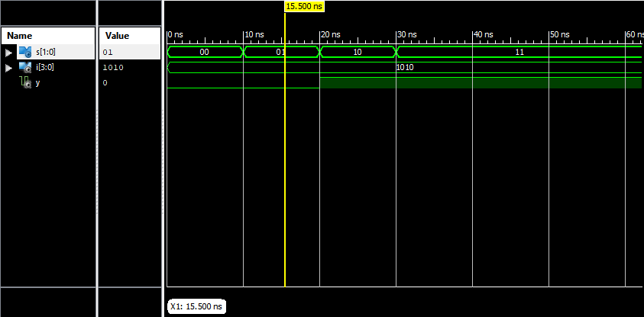

LOGIC DIAGRAM:
Demultiplexer
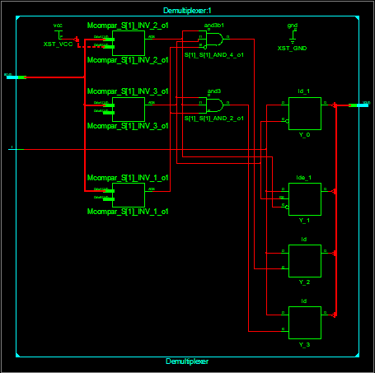
TIMING DIAGRAM:
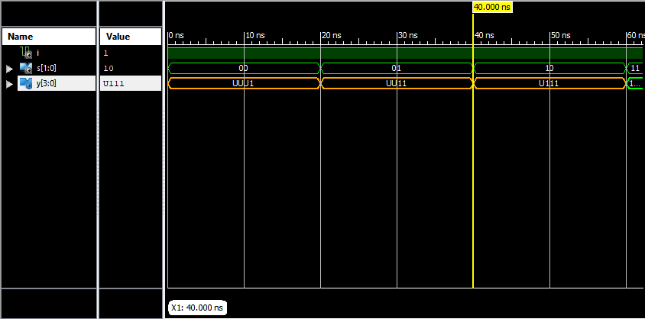
INFERENCE:
Thus the programs for combinational circuits and sequential circuits were simulated using HDL software and its output has been verified.
Mini Project
DONE BY: Priyadarshan V J
Kannan K
Praveen Karthik G
Mothishwaran K
Pugazhandhi G
Roszhan Raj M S
Prasad M
ABSTRACT:
As the number of road users constantly increases and resources provided limited, intelligent traffic signal controller is a very major requirement. Therefore, the need arises for simulating and optimizing traffic control algorithms to better accommodate this increasing demand. However, some limitations to the usage of intelligent traffic control exist. Avoiding traffic jams for example is beneficial to both environment and economy like a decrease in each of delay, number of stops, fuel consumption, pollutant emissions, etc., but improved traffic-flow may also lead to an increase in demand Optimization of traffic light switching increases road capacity and traffic flow, and can prevent traffic congestions.

PRINCIPLE OF OPERATION:
Traffic Light Controller will be used to reduce the harm effects . In this circuit clk and rst_a are two input signal and North_lights, South_lights, East_lights and World_lights are 3 bit output signal. In output signal, "001" represents Green light, "010" represents Yellow light and "100" represents Red light. On the reset signal, design will enter into north state and start giving output after reset will go low. Design will turn on Green light for eight clock cycles and Yellow light for four clock cycles. Design will start with north, then goes into south, then east and finally into west and by this it will keep going.

COMPONENTS / EQUIPMENTS REQUIRED:
1. PC
2. VHDL simulation Software

S.No. | Name of the Pin | Description
1 | North_lights | 001 = Green, 010 = Yellow, 100 = Red
2 | South_lights | 001 = Green, 010 = Yellow, 100 = Red
3 | East_lights | 001 = Green, 010 = Yellow, 100 = Red
4 | West_lights | 001 = Green, 010 = Yellow, 100 = Red
5 | clk | Clock Signal
6 | rst_a | Reset Signal

CODE:
module Traffic_light(North_lights,South_lights,East_lights,West_lights,clk,rst_a);

output reg [2:0] North_lights,South_lights,East_lights,West_lights;
input clk;
input rst_a;

reg [2:0] state;

parameter [2:0] north=3'b000;
parameter [2:0] north_y=3'b001;
parameter [2:0] south=3'b010;
parameter [2:0] south_y=3'b011;
parameter [2:0] east=3'b100;
parameter [2:0] east_y=3'b101;
parameter [2:0] west=3'b110;
parameter [2:0] west_y=3'b111;

reg [2:0] count;

always @(posedge clk, posedge rst_a)
begin
if (rst_a)
begin
state=north;
count =3'b000;
end
else
begin
case (state)
north :
begin
if (count==3'b111)
begin
count=3'b000;
state=north_y;
end
else
begin
count=count+3'b001;
state=north;
end
end

north_y :
begin
if (count==3'b011)
begin
count=3'b000;
state=south;
end
else
begin
count=count+3'b001;
state=north_y;
end
end

south :
begin
if (count==3'b111)
begin
count=3'b0;
state=south_y;
end
else
begin
count=count+3'b001;
state=south;
end
end

south_y :
begin
if (count==3'b011)
begin
count=3'b0;
state=east;
end
else
begin
count=count+3'b001;
state=south_y;
end
end

east :
begin
if (count==3'b111)
begin
count=3'b0;
state=east_y;
end
else
begin
count=count+3'b001;
state=east;
end
end

east_y :
begin
if (count==3'b011)
begin
count=3'b0;
state=west;
end
else
begin
count=count+3'b001;
state=east_y;
end
end

west :
begin
if (count==3'b111)
begin
state=west_y;
count=3'b0;
end
else
begin
count=count+3'b001;
state=west;
end
end

west_y :
begin
if (count==3'b011)
begin
state=north;
count=3'b0;
end
else
begin
count=count+3'b001;
state=west_y;
end
end
endcase // case (state)
end // always @ (state)
end

always @(state)
begin
case (state)
north :
begin
North_lights = 3'b001;
South_lights = 3'b100;
East_lights = 3'b100;
West_lights = 3'b100;
end // case: north

north_y :
begin
North_lights = 3'b010;
South_lights = 3'b100;
East_lights = 3'b100;
West_lights = 3'b100;
end // case: north_y

south :
begin
North_lights = 3'b100;
South_lights = 3'b001;
East_lights = 3'b100;
West_lights = 3'b100;
end // case: south

south_y :
begin
North_lights = 3'b100;
South_lights = 3'b010;
East_lights = 3'b100;
West_lights = 3'b100;
end // case: south_y

west :
begin
North_lights = 3'b100;
South_lights = 3'b100;
East_lights = 3'b100;
West_lights = 3'b001;
end // case: west

west_y :
begin
North_lights = 3'b100;
South_lights = 3'b100;
East_lights = 3'b100;
West_lights = 3'b010;
end // case: west_y

east :
begin
North_lights = 3'b100;
South_lights = 3'b100;
East_lights = 3'b001;
West_lights = 3'b100;
end // case: east

east_y :
begin
North_lights = 3'b100;
South_lights = 3'b100;
East_lights = 3'b010;
West_lights = 3'b100;
end // case: east_y
endcase // case (state)
end // always @ (state)
endmodule

PIN DIAGRAM:
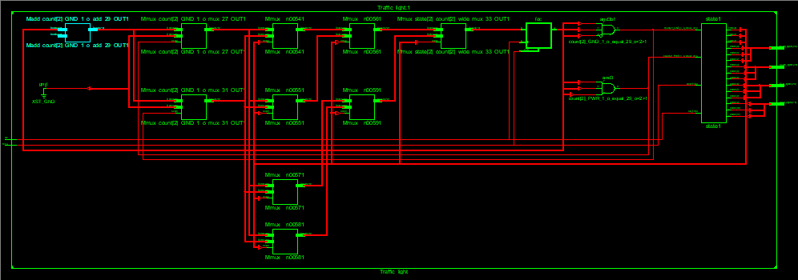
STIMULATION OUTPUT:
